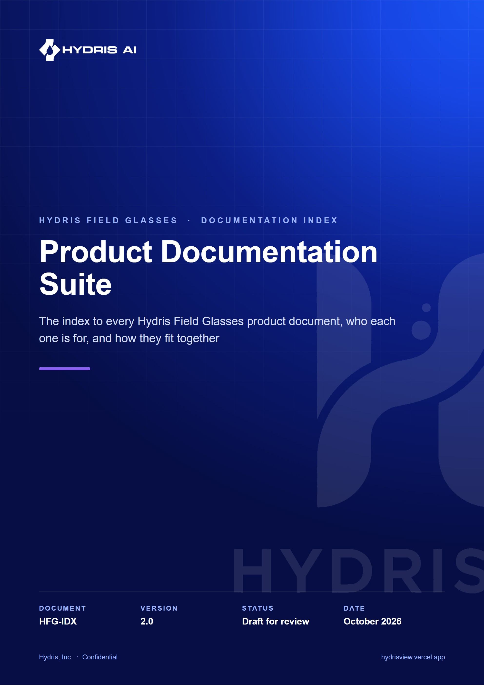
Document control
Document | Product Documentation Suite (HFG-IDX)
Version | 2.0
Status | Draft for review
Owner | Product, Hydris
Audience | Everyone working on or evaluating Hydris Field Glasses
Product | Hydris Field Glasses: website, operator console, glasses app, Android app, API
Source of truth | docs/product/README.md in tarun-km/hydrisview (this Word file is generated from it)
Classification | Confidential: Hydris, Inc. and named partners
Revision history
Version | Date | Author | Changes
2.0 | October 2026 | Product, Hydris | Expanded suite: twelve documents, Word editions with diagrams, new Design System and Operations Runbook

Contents
1 The documents 4
2 Where to start 5
3 The product on one page 6
4 How the Word editions are made 7
5 Status conventions 9

Hydris Field Glasses puts live plant telemetry, guided inspections, approved procedures, audit-record scanning and a grounded voice assistant in the field of view of wastewater and effluent treatment operators. One account powers four surfaces: the website, the operator console, the glasses app and the native Android app, all backed by one API.
This suite is the reference for building, deploying, operating and evolving that product. Every document has a Markdown source in this folder (the source of truth, reviewed like code) and a branded Word edition in word/ with a cover, document control, a contents page, numbered chapters, diagrams and captioned tables.

1 The documents
Table 1. The Hydris Field Glasses documentation suite
# | Document | ID | Answers | Primary readers
00 | Documentation Index | HFG-IDX | What exists and where to start | Everyone
01 | Product Requirements | HFG-PRD | What we build, for whom, why, and how we measure success | Product, leadership, engineering, pilots
02 | Architecture | HFG-ARC | How the system is structured and why | Engineering
03 | Data Model | HFG-DAT | Every table, field, state and tenancy rule | Engineering, data, security
04 | API Reference | HFG-API | Every endpoint, payload, error and event | Engineering, integrators
05 | Mobile App Specification | HFG-MOB | The native Android app, screen by screen | Mobile engineering, design, QA
06 | Glasses Integration | HFG-GLS | How Ray-Ban Meta and display glasses connect | Engineering, field support
07 | Design System and UX | HFG-DSN | Tokens, components and hands-free interaction rules | Design, front-end, mobile
08 | Deployment and Infrastructure | HFG-DEP | Where Hydris runs and how it ships | Platform engineering
09 | Security and Privacy | HFG-SEC | Threats, controls, privacy and compliance mapping | Security, legal, customers
10 | QA and Test Plan | HFG-QA | How quality is proven, release by release | QA, engineering
11 | Operations Runbook | HFG-OPS | Onboarding, support, troubleshooting, incidents | Customer success, support
12 | Roadmap and Future Features | HFG-RMP | Where the product goes next, and in what order | Leadership, product, partners

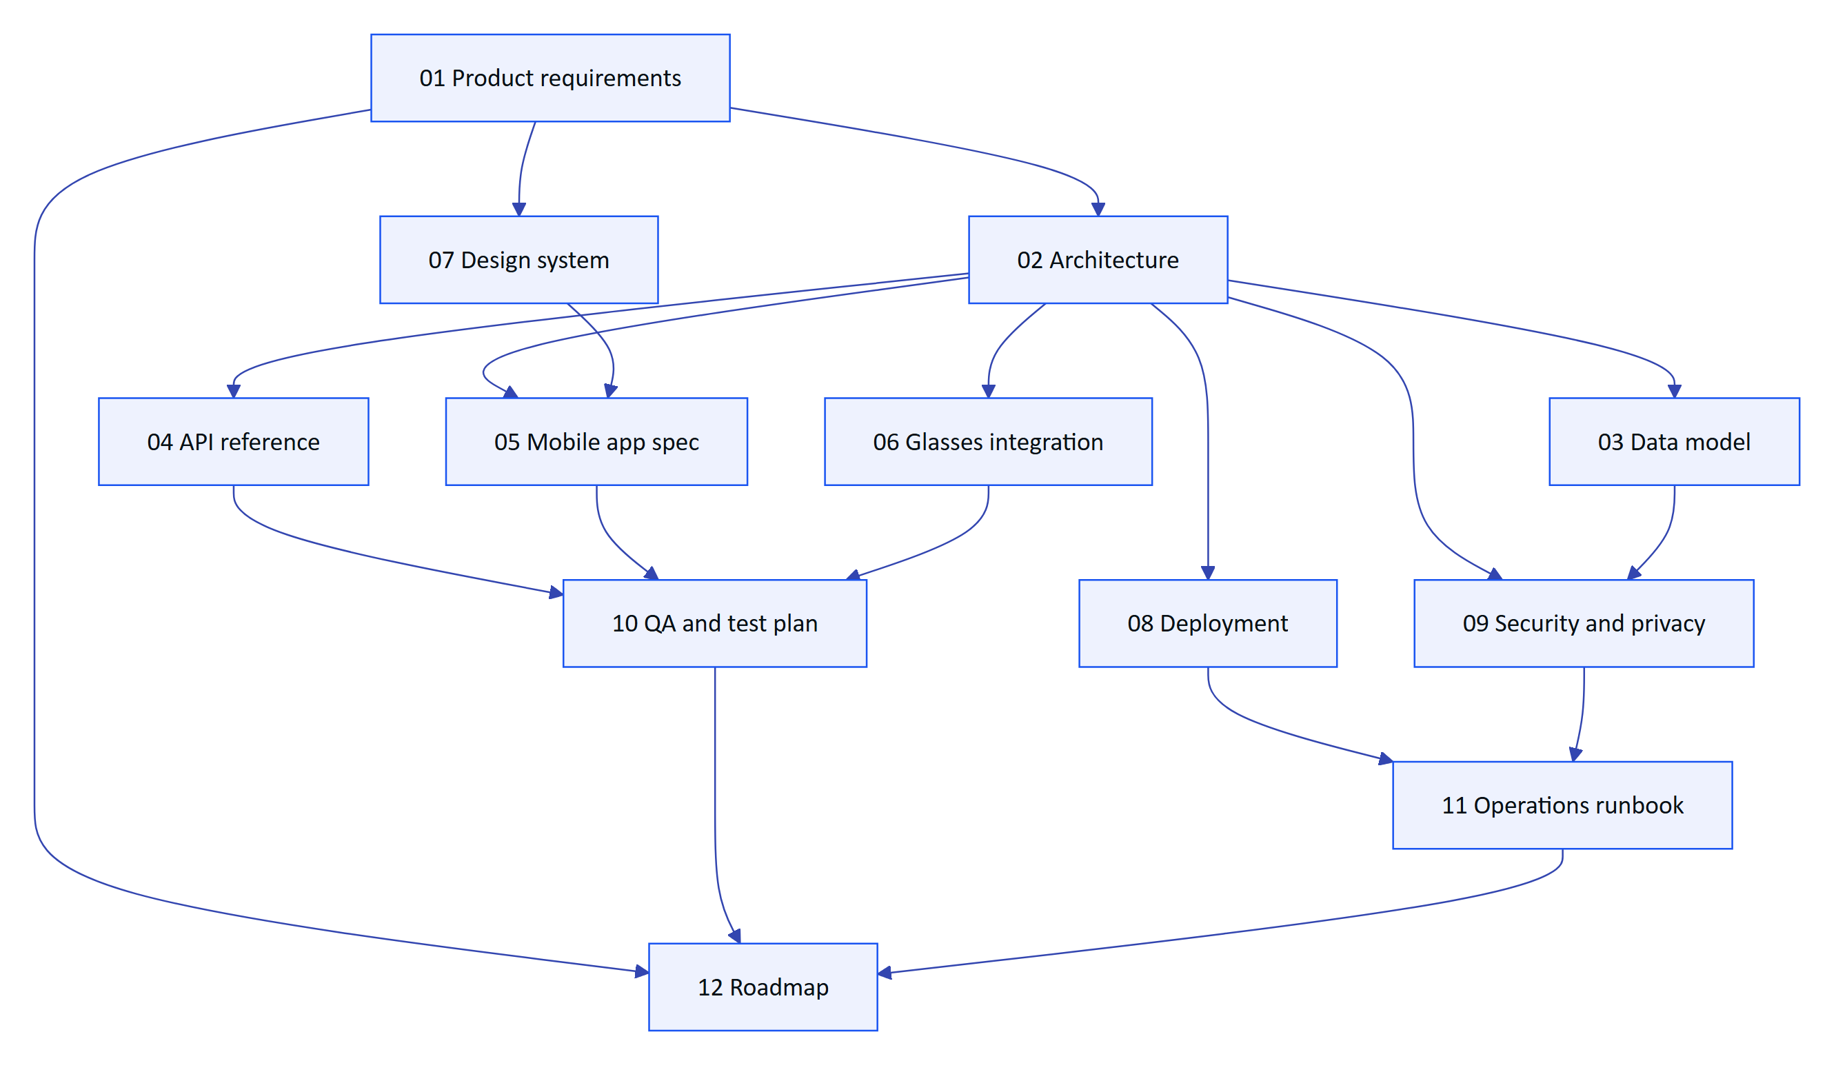
Figure 1. How the documents relate: requirements flow into design and build documents, which flow into run and prove documents

2 Where to start
Table 2. Suggested reading paths by role
If you are | Read first | Then
New to Hydris | 01 Product requirements (executive summary and personas) | 02 Architecture (system context), 12 Roadmap
Back-end engineer | 02 Architecture, 03 Data model | 04 API reference, 09 Security, 10 QA
Android engineer | 05 Mobile app spec, 06 Glasses integration | 07 Design system, 04 API reference
Web or console engineer | 07 Design system, 04 API reference | 02 Architecture, 10 QA
Designer | 07 Design system, 01 Product requirements (journeys) | 05 Mobile app spec
Platform or DevOps | 08 Deployment, 09 Security | 11 Operations runbook
Customer success or support | 11 Operations runbook | 06 Glasses integration, 01 Product requirements
Customer security reviewer | 09 Security and privacy | 03 Data model, 08 Deployment
Leadership or investor | 01 Product requirements, 12 Roadmap | 08 Deployment (cost model)

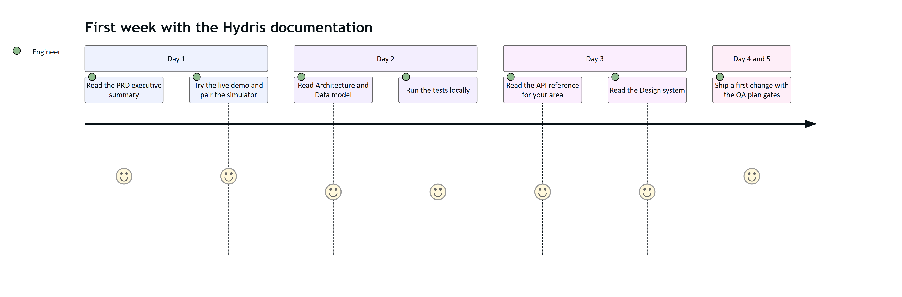
Figure 2. Reading journey for a new engineer joining the Hydris team

3 The product on one page
4  product surfaces  website, console, glasses app, Android app |  | 1  account everywhere  the same data on every surface |  | 2  people per audit record  field review, then a different approver |  | 12  documents  in this suite

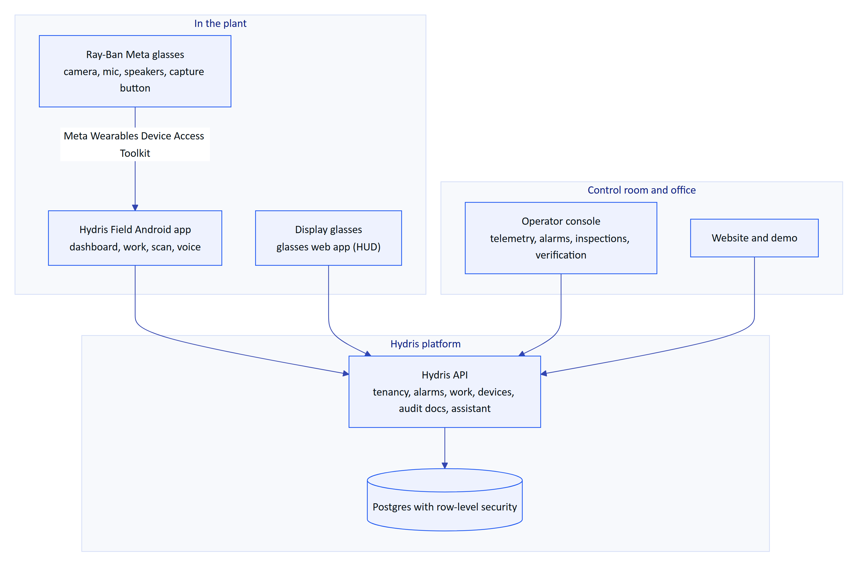
Figure 3. Hydris Field Glasses at a glance
The core loops the product supports:
- See and act on the plant: live readings and alarms reach the operator on the glasses or phone, with acknowledgement and investigation from the field.
- Do the work right: inspections and maintenance rounds with checklists and approved SOPs, hands-free.
- Turn paper into verified records: scan a paper audit sheet with the glasses or phone camera; values are read twice on the device, checked for plausibility, confirmed by a reviewer against the paper and approved by a second person before a searchable PDF is produced.
- Ask the plant: "Hey Hydris, what is the current pH?" is answered from the account's own data, never invented.

4 How the Word editions are made
The Word files are generated, so they never drift from the Markdown. Edit the Markdown, then rebuild.
cd docs/product/tools
npm install
node check.js # every diagram renders, front matter and house style
node build.js # Markdown and Mermaid to branded Word files in ../word
powershell -File finalize.ps1 # Windows with Word: fill contents pages, export PDFs to ../word/pdf
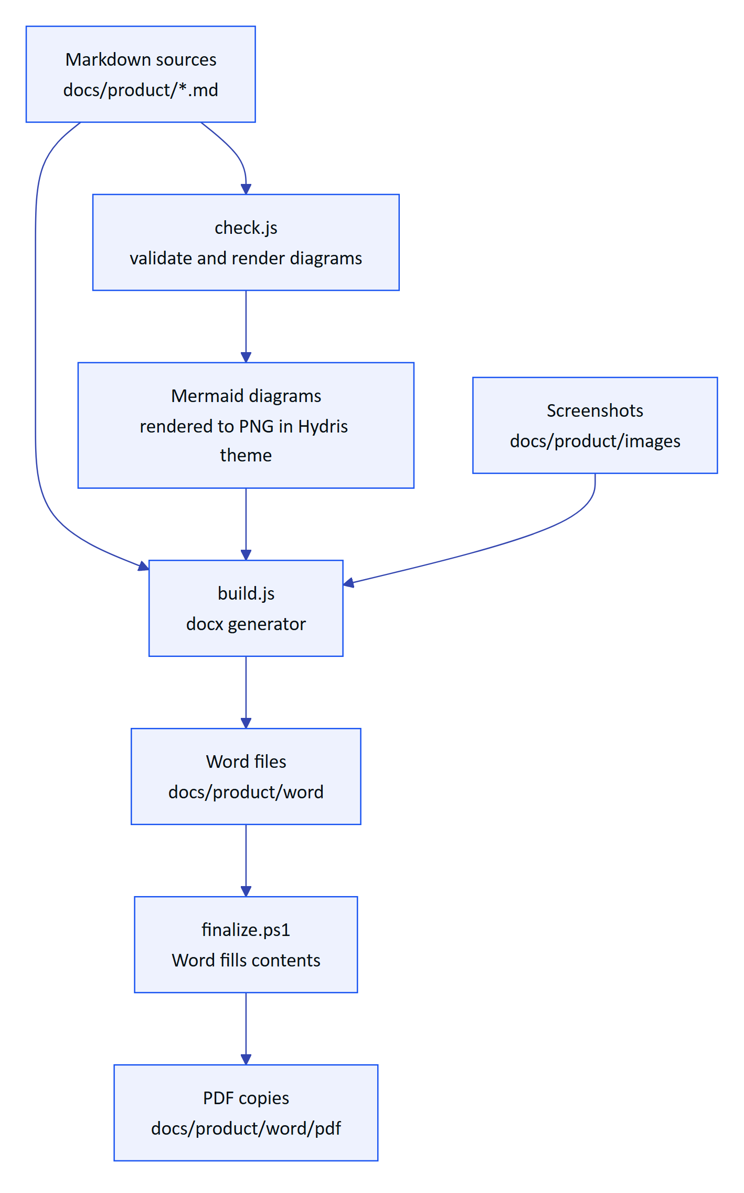
Figure 4. Documentation build pipeline
NOTE
Authoring conventions (captions, callouts, KPI tiles, diagram types, house style) are in tools/AUTHORING.md. Screenshots of the web surfaces can be refreshed from the live site with node screenshots.js.

5 Status conventions
Every document uses the same status words so readers can tell what exists today from what is planned.
Table 3. Status vocabulary used across the suite
Status | Meaning
Built | In the code on main and exercised by tests or the live demo
Partial | Exists but incomplete, or only on some surfaces
Planned | Agreed direction, not yet built
Target | A goal value, not a measurement
Estimate | A modelled value, labelled with its assumptions

IMPORTANT
Ray-Ban Meta support depends on Meta's Wearables Device Access Toolkit and the Meta AI app, which stays installed on the phone for pairing, permissions and firmware. Hydris replaces the Meta AI app for daily work, not for those functions. See 06 Glasses integration.

